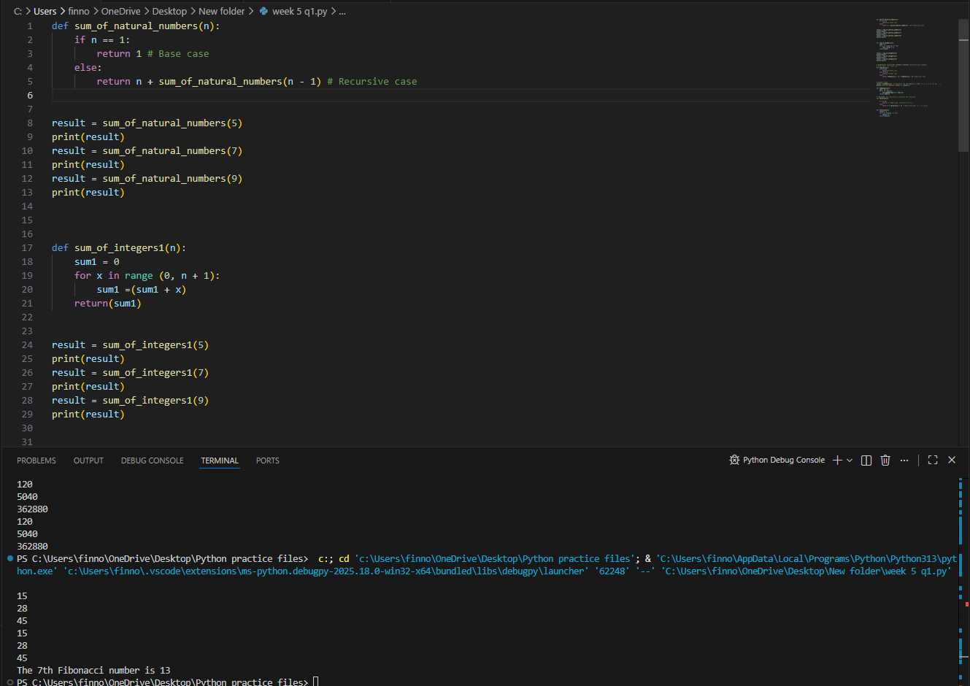
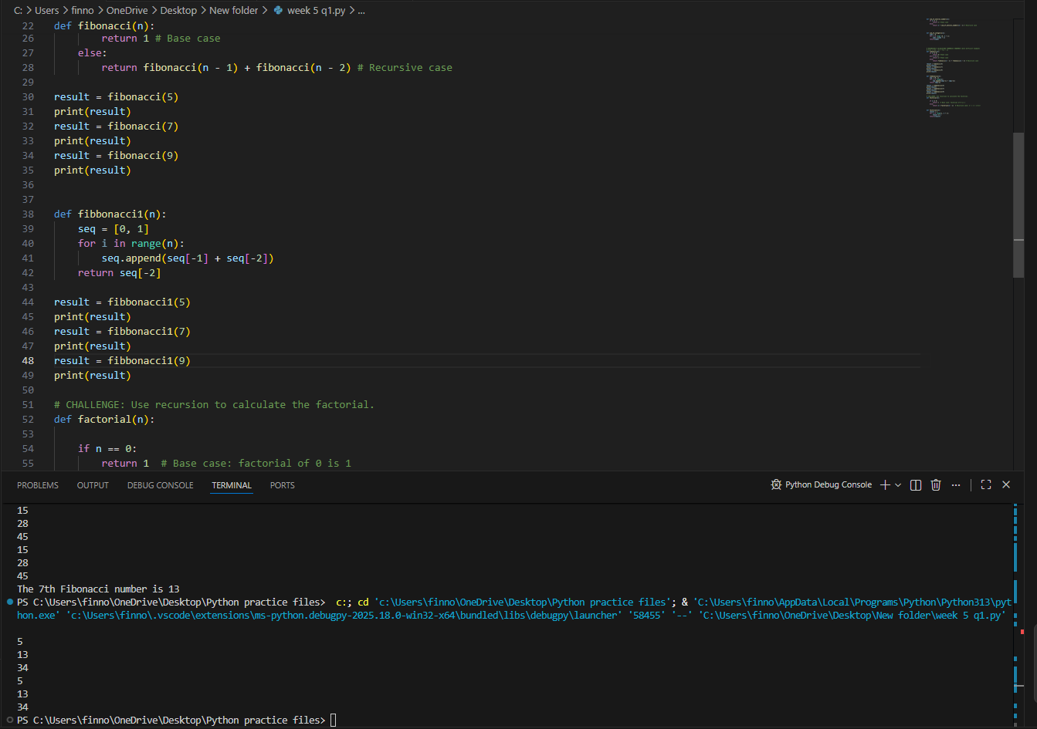
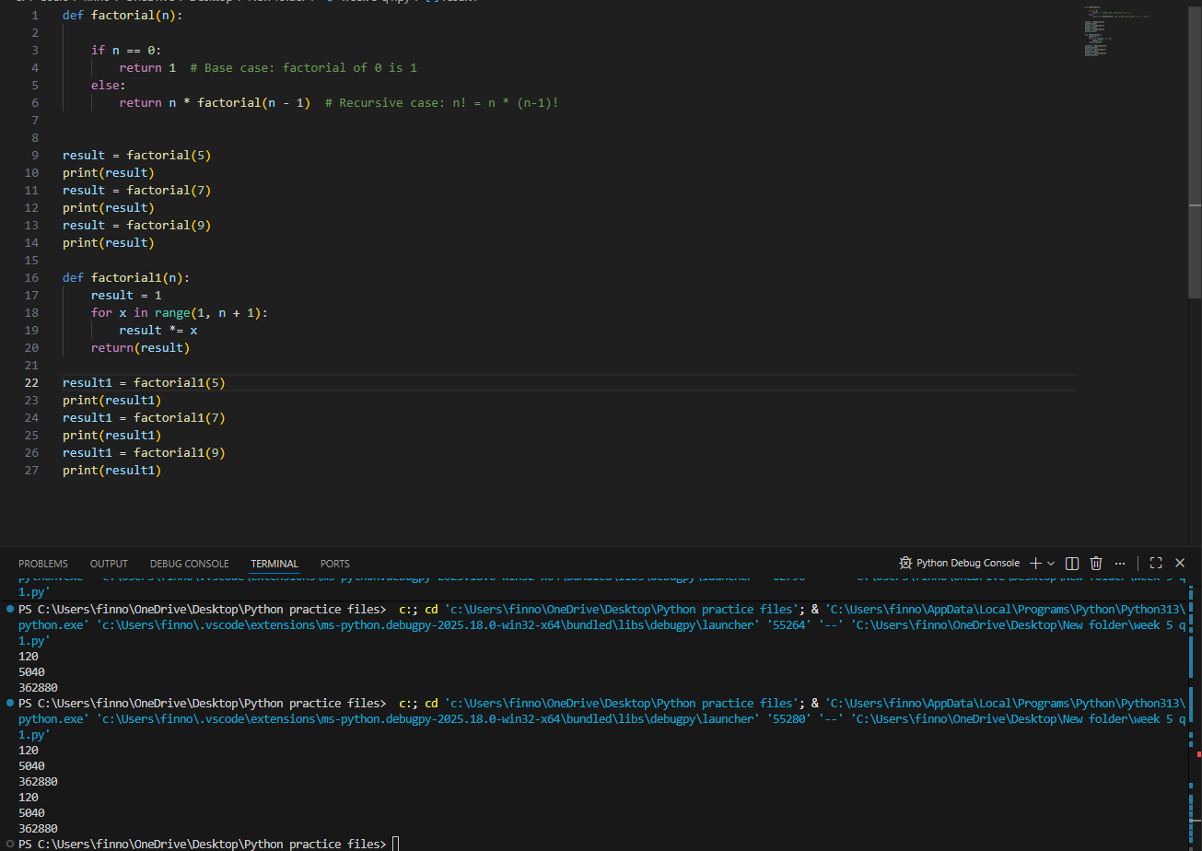

Q2:


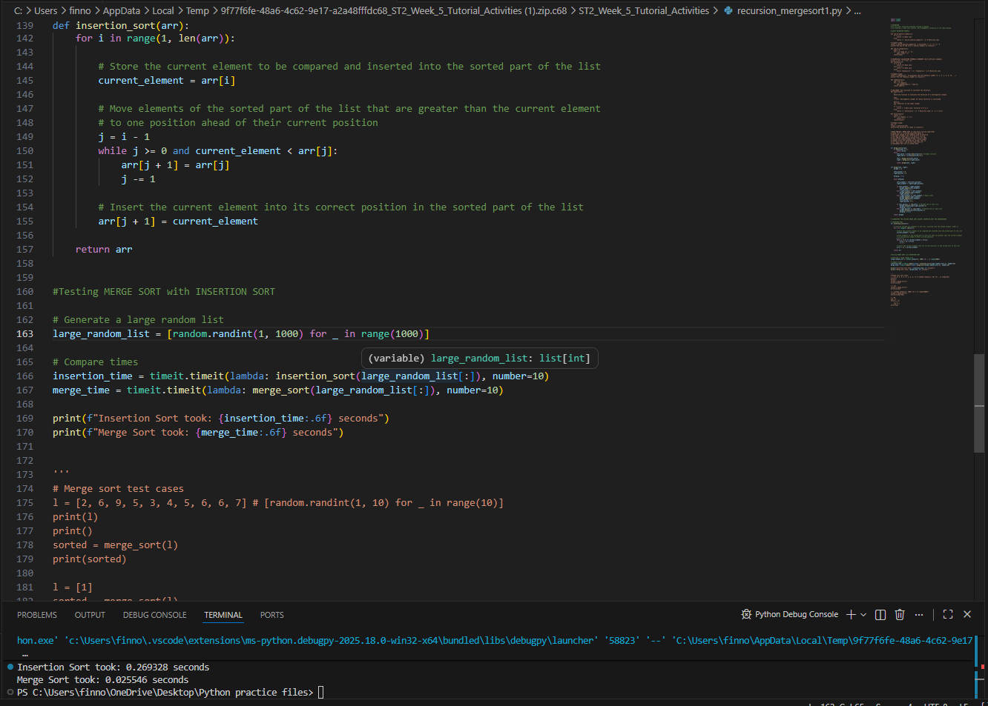
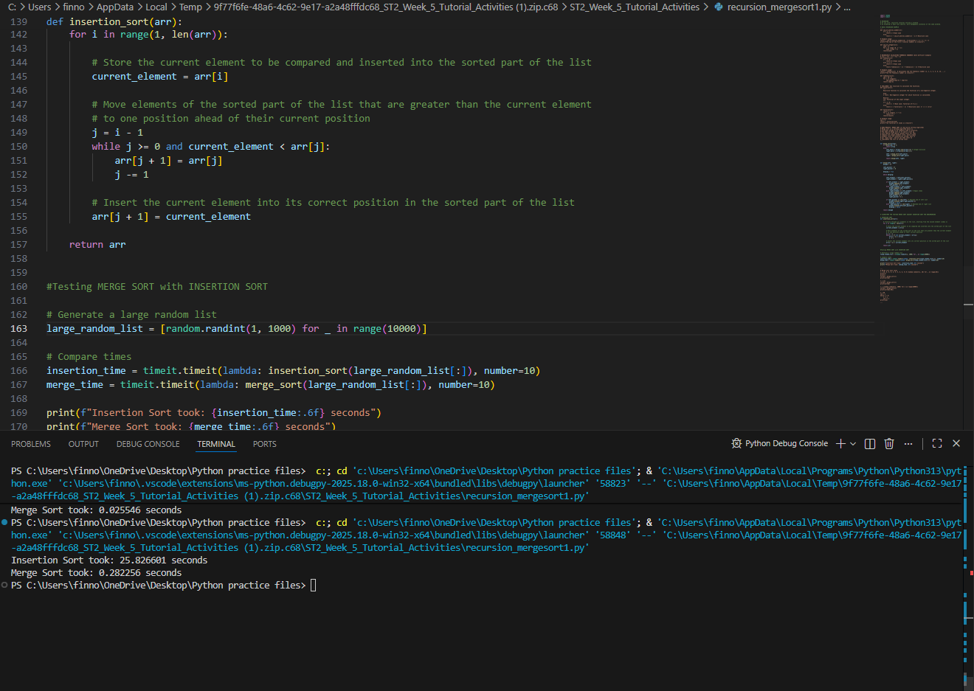
Merge sort has a time complexity of $O(nlog⁡n)$, whereas insertion sort has a best-case time complexity of $O(n)$. This difference arises from how each algorithm processes data.
Insertion sort iterates through each piece of data and decides on the position that piece of data need to take within the overall data set. In the best case scenario insertion sort still must iterate through each object once.
In contrast, merge sort follows a divide-and-conquer approach. It repeatedly splits the list into smaller sub lists until each contains a single element and then merges these sub lists back together in a sorted manner. This is far more efficient as it can compile multiple pieces of data at once leading to $O(nlog⁡n)$time complexity

Q3
1
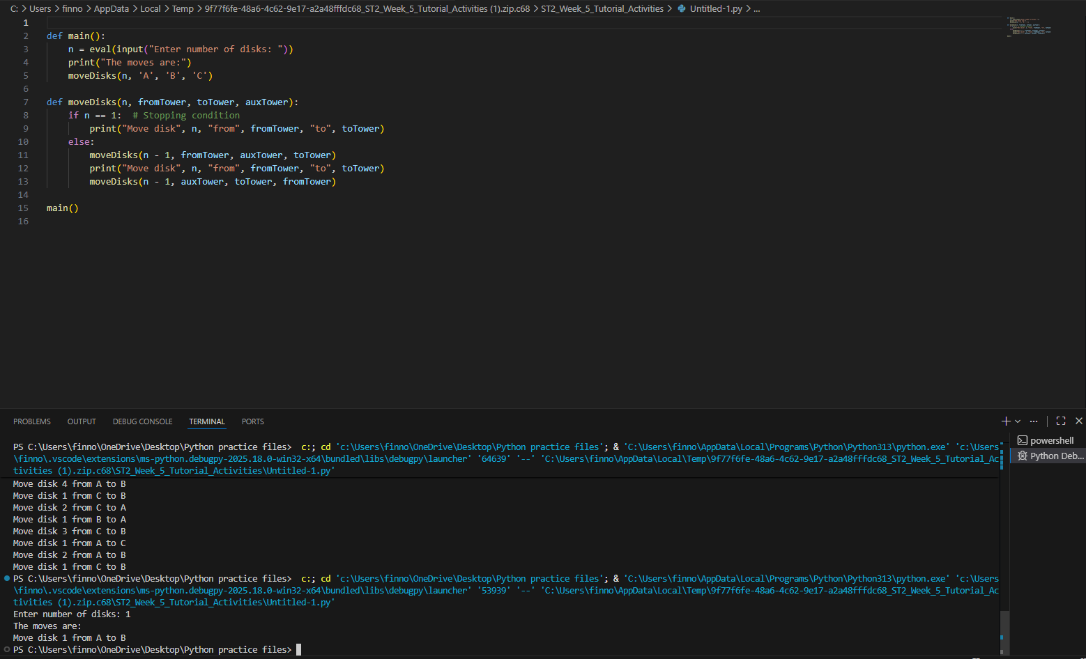
2
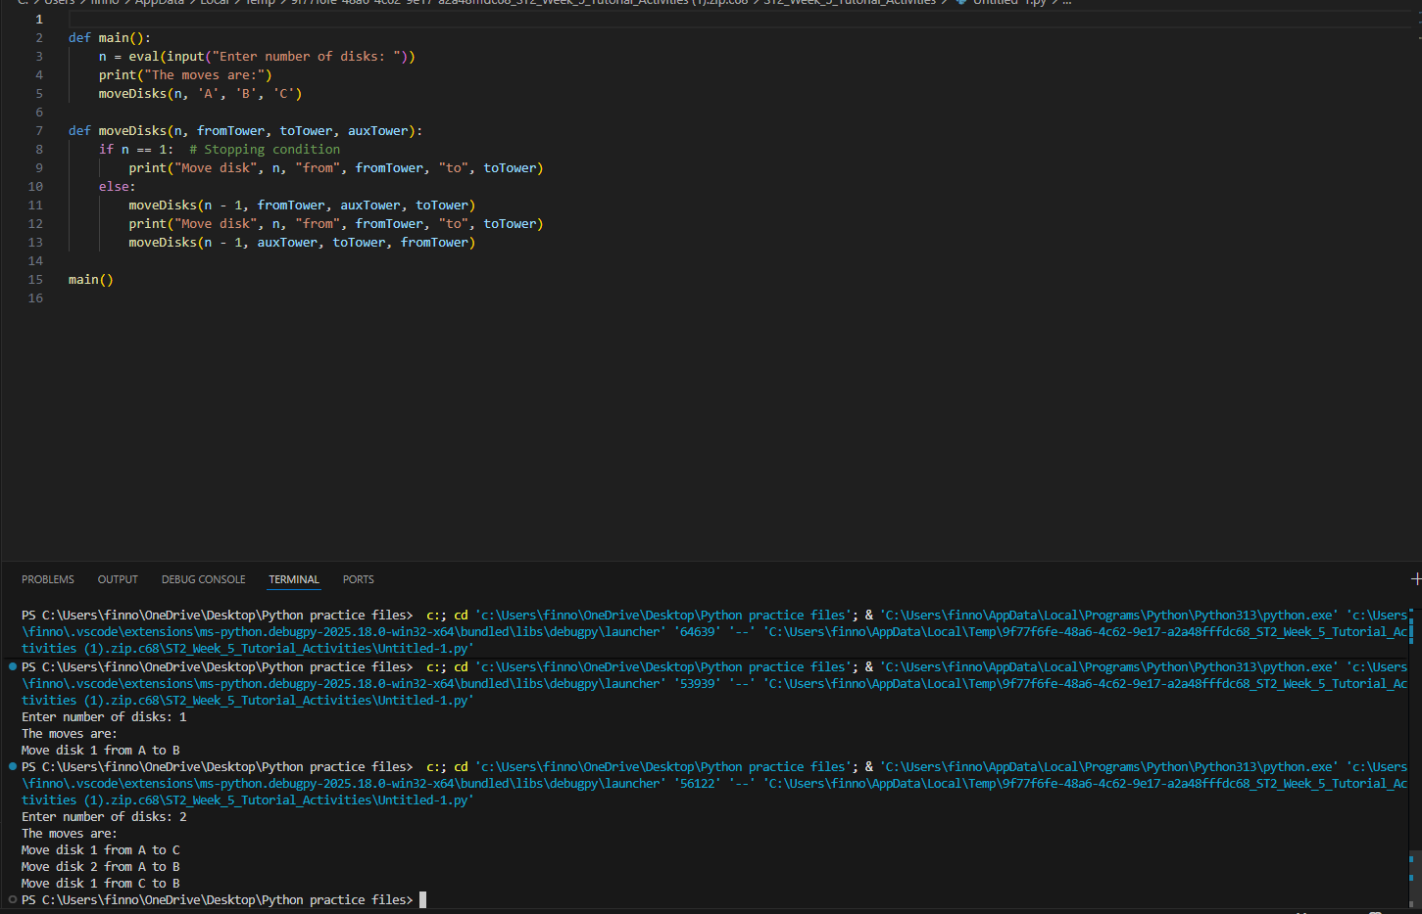
6
